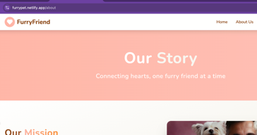 Remove the our story section from all pages. Done

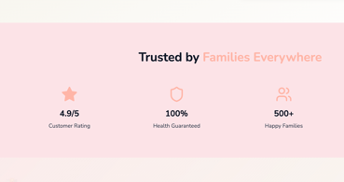 Remove this section as well. Done

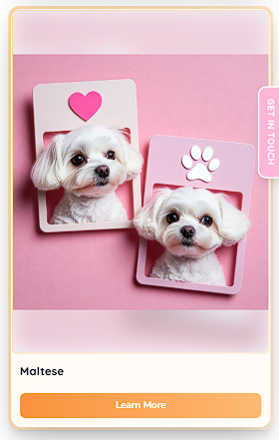

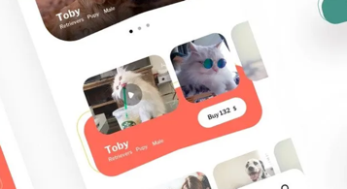 Breed card for home page mien aisa kuch creative karde. know more ka button bhi daalna hai iss card mien to open the breed page then. Done.

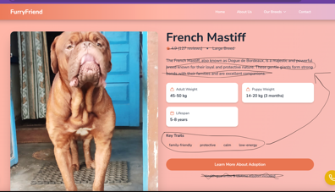 Key traits wali line mien kuch icon daalde mast sa saare traits k sath and move it to the top below the Title

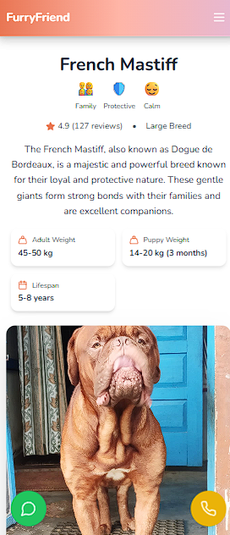
Change learn more about adoption or Request quote and attach contact form to it. And remove the line below the button.

Done.

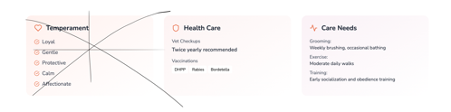 Remove the temperament section and move the rest 2 cards to top with puppy weight and lifespan cards and integrate design. Mobile first approach se adjust kar lena design
Done.

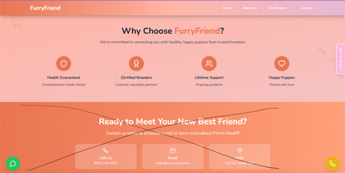 Remove neeche waala section and why choose furryfriend waala section thoda standout karwana hai need something creative for this .
Done.

Why choose furry friend section needs to come after puppy and adult stage section and gallery in the end

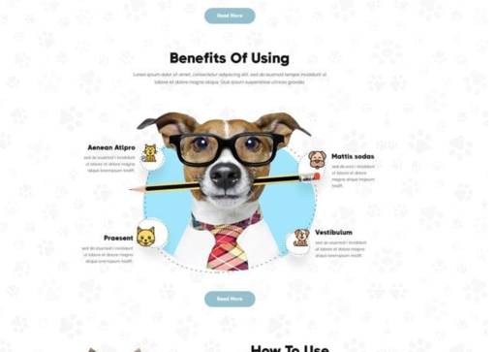 Need something like this for why choose furry friend
section
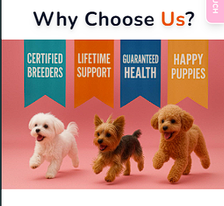 Done.

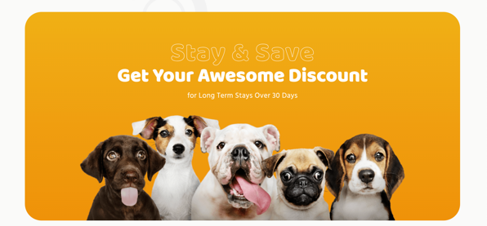 Ready to meet our best friend ki jagah aisa sa kuch section daalde in the end of all pages as a contact option….aise graphic mien upar k text ki teeno line hatade ek button daalde ‘get your awesome discount’ jitna bade usmien “ Contact us to get your best friend likhde
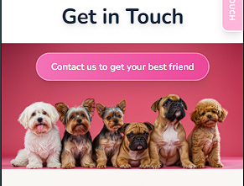 Done.

